Election Time

Civic Mirror Reflection

1. In your opinion, what is the most important thing that the citizens and government of your nation should consider heading into the Hex Auction?

I think the government and citizens heading into the hex auction need to be selfless. As we know there is a large wealth gap in this nation and this will create a steep in equality in the nation with the rich buying up property and the poor having nothing to do. Citizens should also put aside their hidden agendas, if every citizen follows their goals it could ruin the country by creating an unequal atmosphere. Now the government should also consider a few things, the government should purchase property to prevent this inequality from happening. The government should also focus on nationalizing sectors to prevent high prices for sectors like energy, education, and healthcare however this could put the government in significant debt. Finally the government and the people should create a dedicated plan, the government should create a plan to have a sustainable and fair system, but the government should also reach out to the populous to create a plan resembling a sort of semi planned economy. This planned economy would create a sustainable market so every person is treated fairly.

1. Why are political parties so important in the parliamentary process and how their roles change in majority and minority governments? What type of parliamentary government is better: majority or minority? Explain.

Political parties are important because they create a unified policy for constituents to make an educated decision. If there were no political parties then a prime minister could not be elected which is very important to our current democratic system. Without political parties citizens would have a hard time to choose the right candidate and the system would be very inefficient. In a majority government political parties are important because they create a unified policy for the majority government and they can get policy done efficiently. In minority governments however their roles change significantly, their role is to push their political agenda however in a way that would benefit a majority Canadians. Wherein a majority government the party can push legislation regardless of the opinion of the opposition minority governments have to compromise with other parties to create the best legislation that would please the most. There are arguments for each side of a story for a minority government and a majority government. However a minority government is arguably the most democratic and fair system. Under a minority government it gives a say to all Canadian parties because parliament would require bi-partisan support where as a majority government can push legislation without the say of the rest of the possibly 49% of the population. It could be argued that a majority government is more efficient and pass legislation quickly however a dictatorship also can push policy quickly. The best option would be to have a minority government which would create an environment which would force parties to reach across party lines to cooperate, creating a better, more unified government even though they do not belong to the same party. This would also create an atmosphere where the government has a very similar agenda every election so governments will actually be more efficient since they would agree with the legislation actually passed and not repeal it.

1. The Greek philosopher Plato argued that democratic elections were tests of public speaking skills rather than tests of statesmanship and leadership. Do you think this statement is true of the elections you just had? Of elections in Canada? Of democracy in general? Explain.

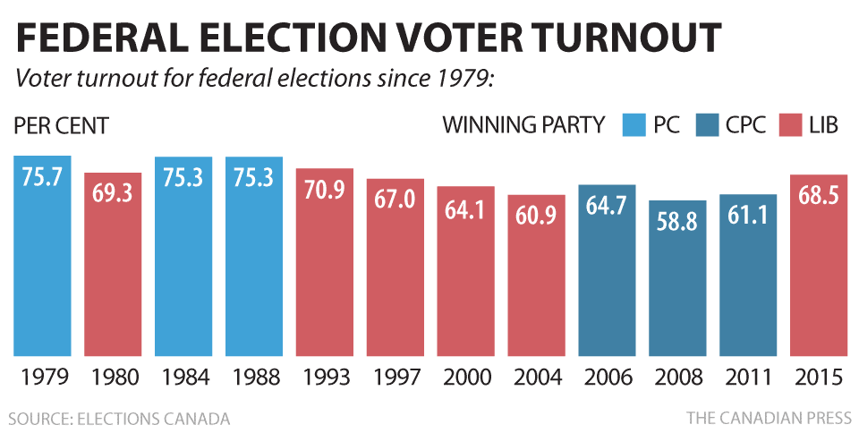Plato is correct in modern politics elections are focused around the leader and how well they communicate to the public. If a leader with bad policies has good public speaking skills they will always win against a leader with good policies who has poor public speaking skills. In the recent American presidential election president Donald Trump had very oppressive and insane policies however he won because he knew how to rally the public. That is the problem with modern politics even in Canada, the problem is with the current media system. After debates the media doesn’t air or write about the policies talked about they focus on the zingers and the insults rather then what actually matters. But this is a problem with the current society people are not as interested in politics as they should be, with voter turnout at a low with the recent 2005 election only 68.5% (Figure 1) of eligible voters voted. This low voter turnout results in an uninformed society which doesn’t focus on policy and instead focuses on what is the most enjoyable.

Figure 1